Polygon–Circular Closed Shapes
# Source: AI Source: Provided by: [Data Path: Persons Table -> ID Column: 1, Name_En Column: Motasem Essam] -> From: [ChatGPT] on [7/25/2026]
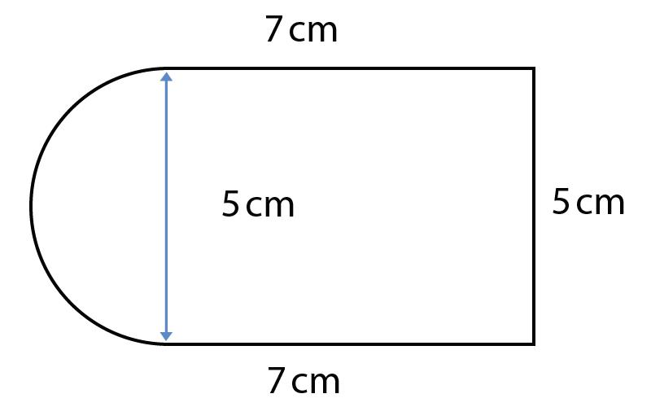
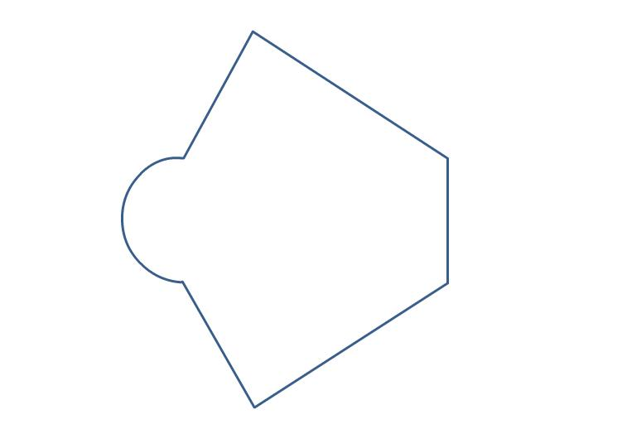
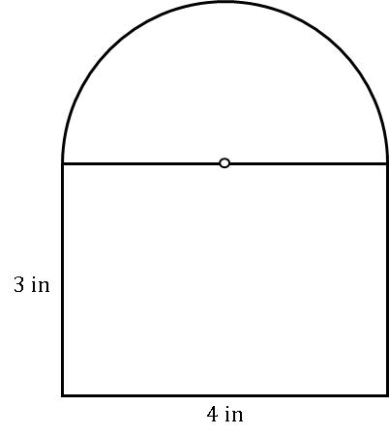
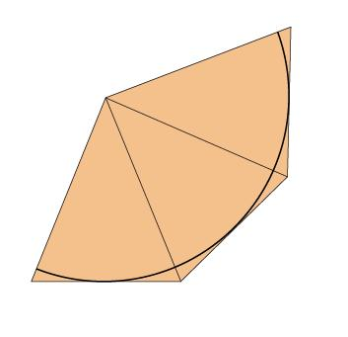
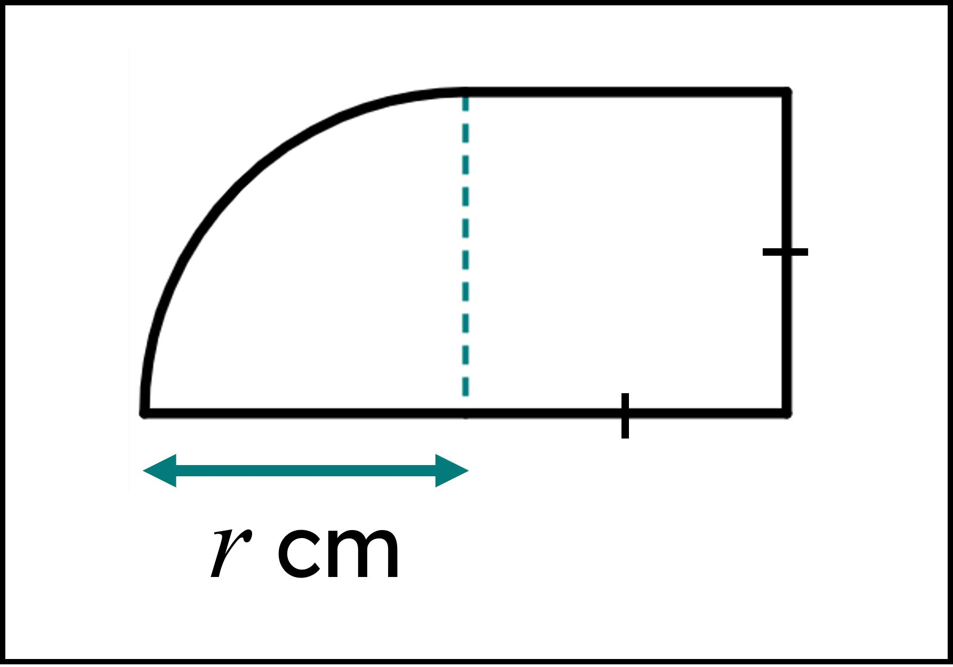

Definition
# Source: AI Source: Provided by: [Data Path: Persons Table -> ID Column: 1, Name_En Column: Motasem Essam] -> From: [ChatGPT] on [7/25/2026]
A Polygon–Circular Closed Shape is a closed mixed shape whose boundary combines straight polygonal segments with circular arcs or complete circular portions.
$$\boxed{\text{Polygon–Circular Closed Shape}=\text{Polygonal Segments}+\text{Circular Curves}+\text{Closed Boundary}}$$
It is classified as a mixed shape because its boundary contains both:
- Straight segments → polygonal component
- Curved circular portions → circular component

Types of Polygon–Circular Closed Shapes

1. Triangle–Circular Closed Shape
# Source: AI Source: Provided by: [Data Path: Persons Table -> ID Column: 1, Name_En Column: Motasem Essam] -> From: [ChatGPT] on [7/25/2026]
A closed shape combining triangular sides with one or more circular arcs.
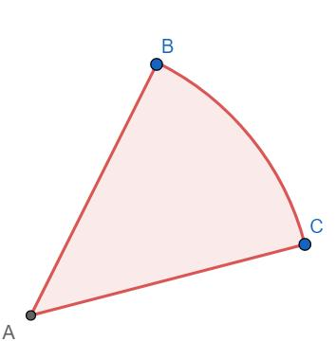
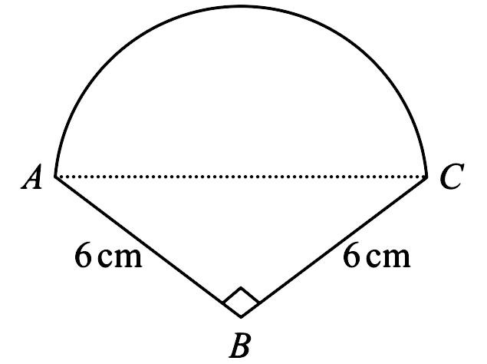
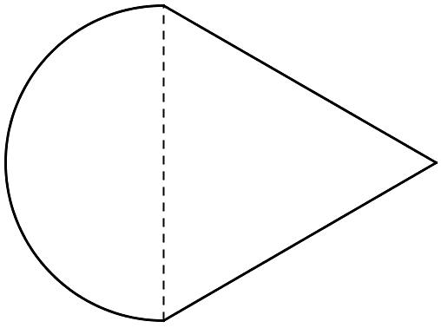
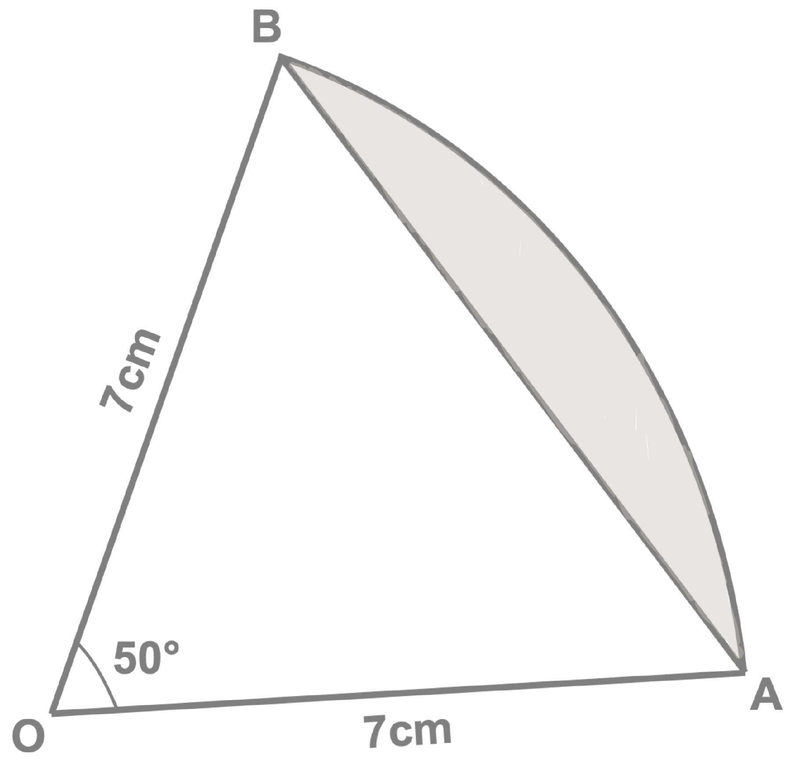
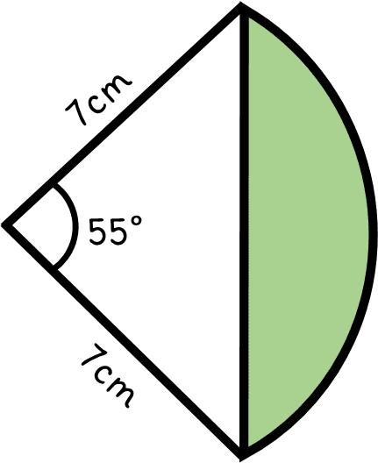
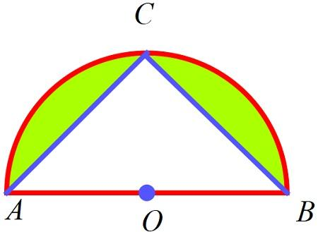
Typical construction:
$$\boxed{\text{Triangle}+\text{Circular Arc}}$$

2. Quadrilateral–Circular Closed Shape
# Source: AI Source: Provided by: [Data Path: Persons Table -> ID Column: 1, Name_En Column: Motasem Essam] -> From: [ChatGPT] on [7/25/2026]
A closed shape combining four-sided polygonal portions with circular arcs.
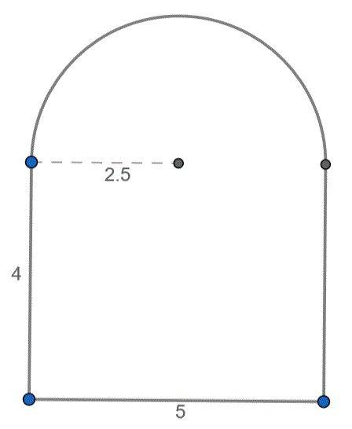
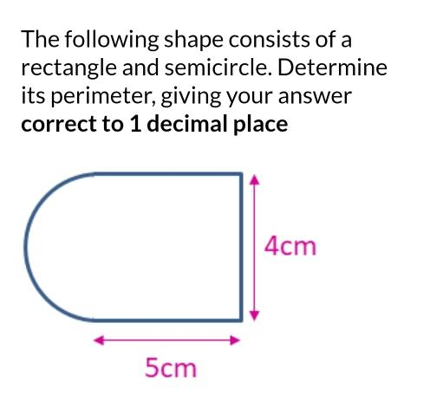
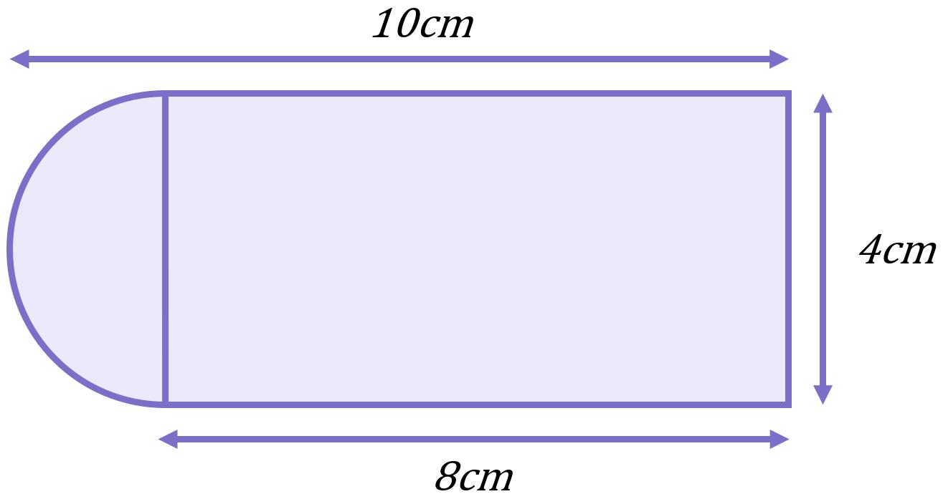
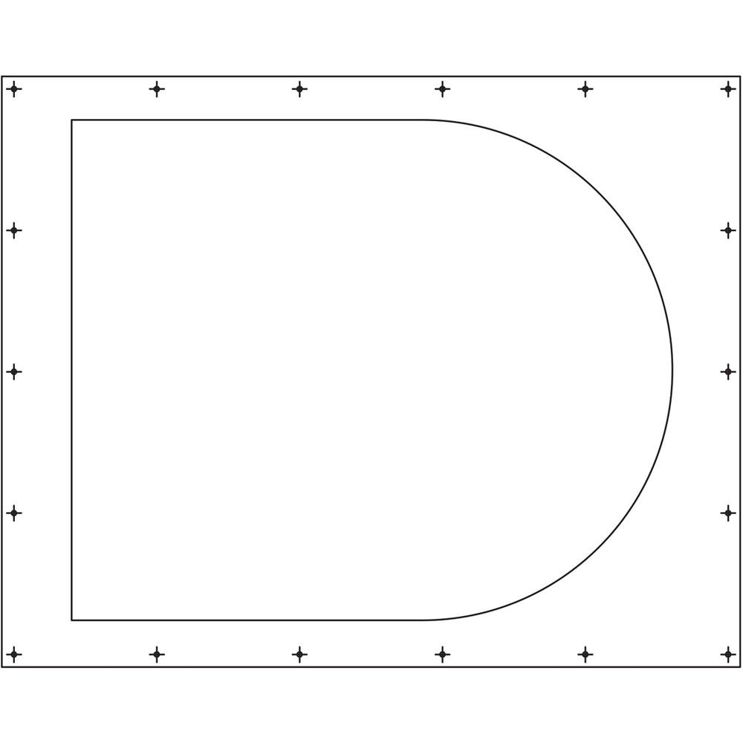
A common example is a rectangle with a semicircular end.

3. Pentagon–Circular Closed Shape
# Source: AI Source: Provided by: [Data Path: Persons Table -> ID Column: 1, Name_En Column: Motasem Essam] -> From: [ChatGPT] on [7/25/2026]
A five-sided polygonal component combined with one or more circular portions.
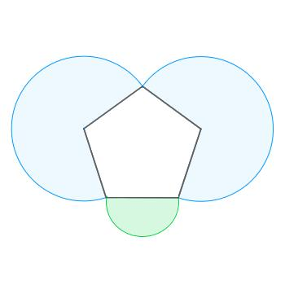
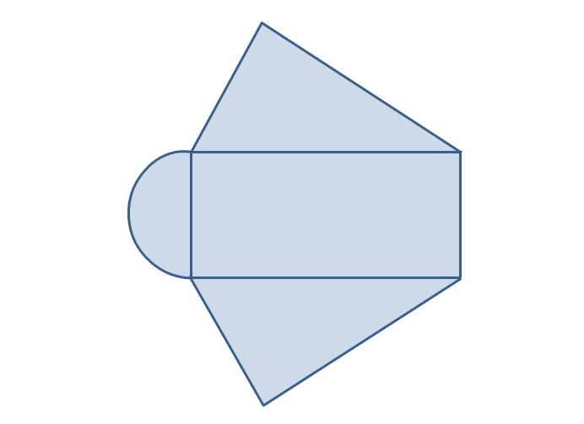
The straight portions form part of the boundary while circular arcs complete the remaining boundary.

4. Hexagon–Circular Closed Shape
# Source: AI Source: Provided by: [Data Path: Persons Table -> ID Column: 1, Name_En Column: Motasem Essam] -> From: [ChatGPT] on [7/25/2026]
A six-sided polygonal component combined with circular arcs.
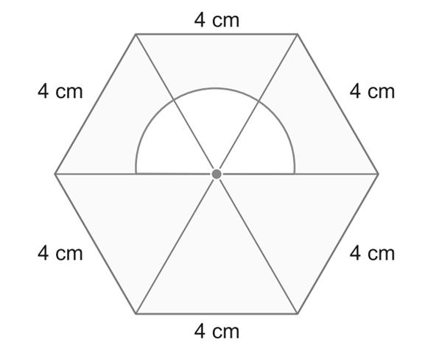
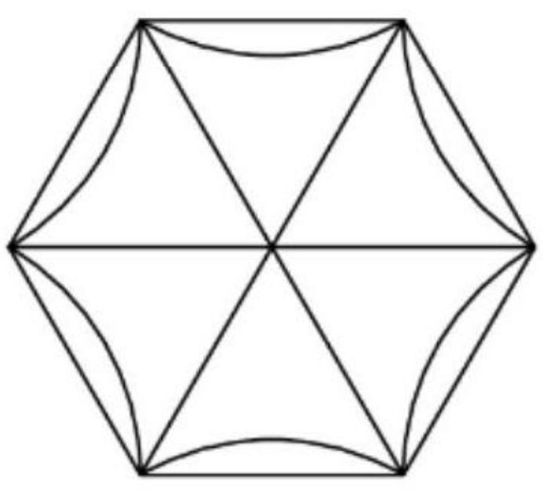
This type can be regular-looking or irregular depending on the polygon and circular portions.

5. Polygon–Semicircular Closed Shape
# Source: AI Source: Provided by: [Data Path: Persons Table -> ID Column: 1, Name_En Column: Motasem Essam] -> From: [ChatGPT] on [7/25/2026]
A polygon combined with one or more semicircular boundaries.
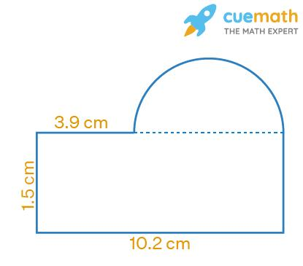
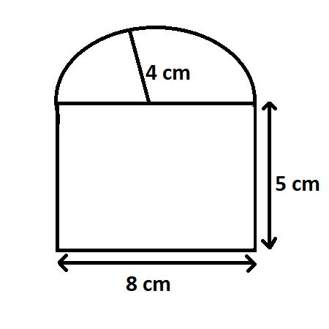
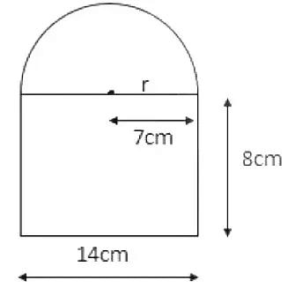
For example:
$$\boxed{\text{Rectangle}+\text{Semicircle}}$$
is a polygon–circular mixed shape.

6. Polygon–Quarter-Circular Closed Shape
# Source: AI Source: Provided by: [Data Path: Persons Table -> ID Column: 1, Name_En Column: Motasem Essam] -> From: [ChatGPT] on [7/25/2026]
A polygonal boundary combined with quarter-circle arcs.
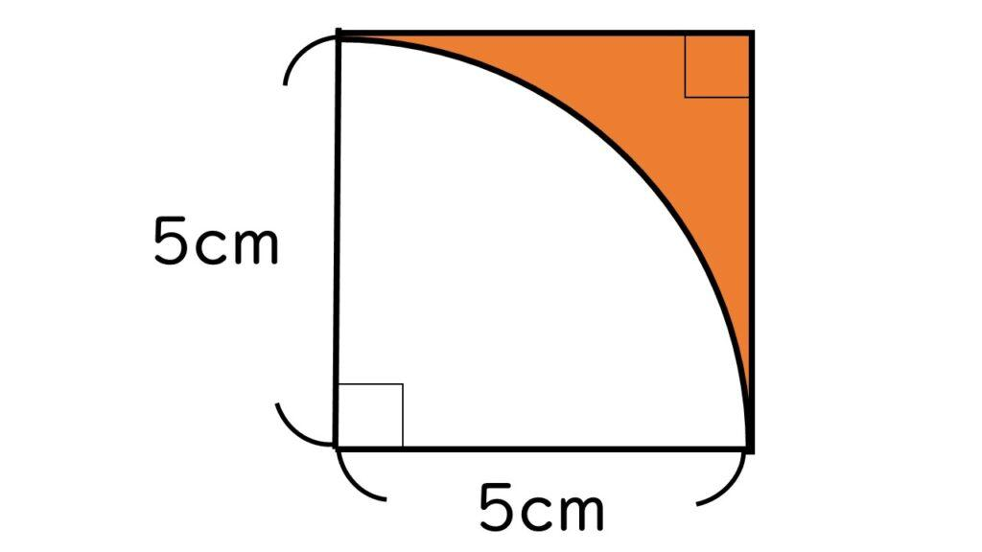
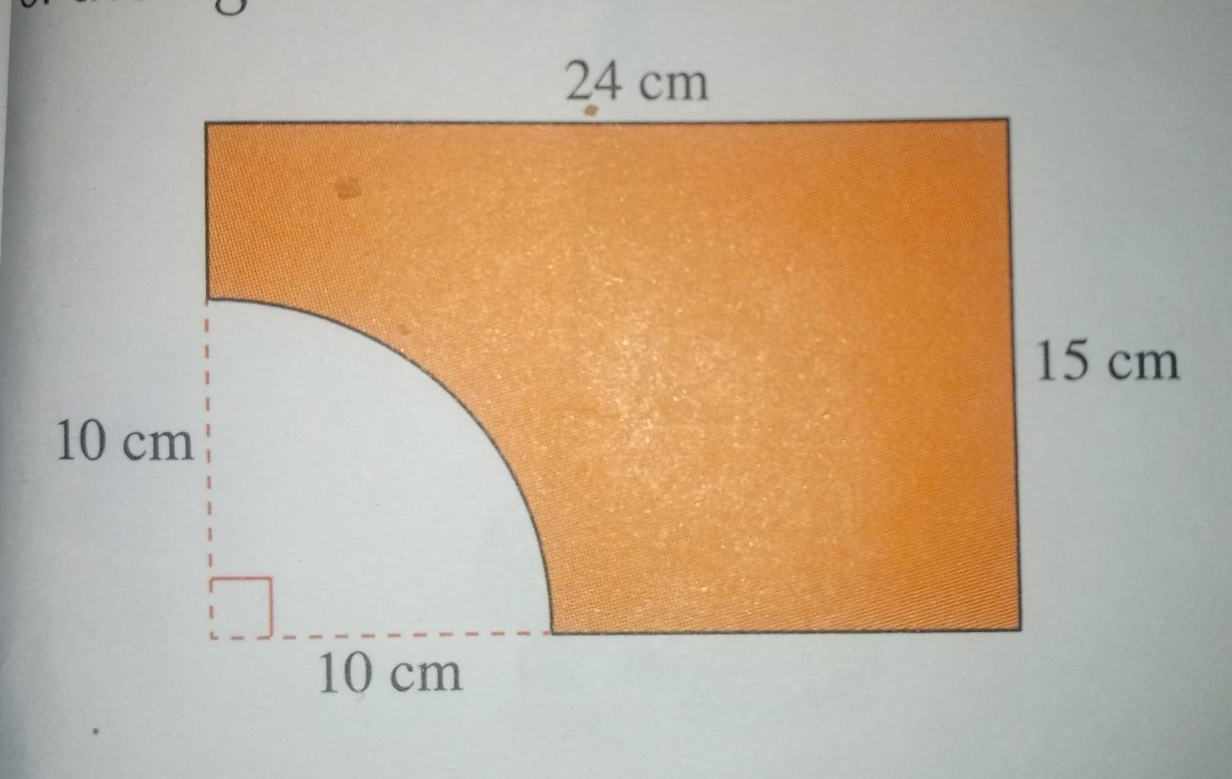
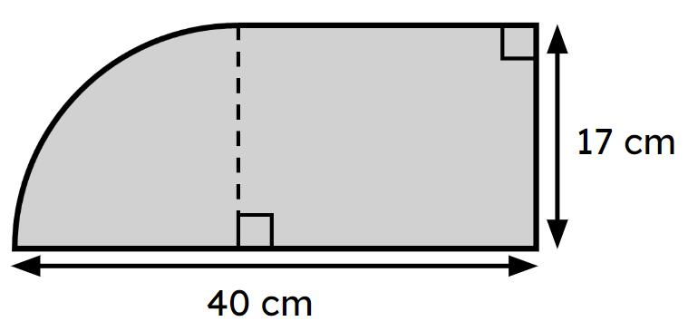
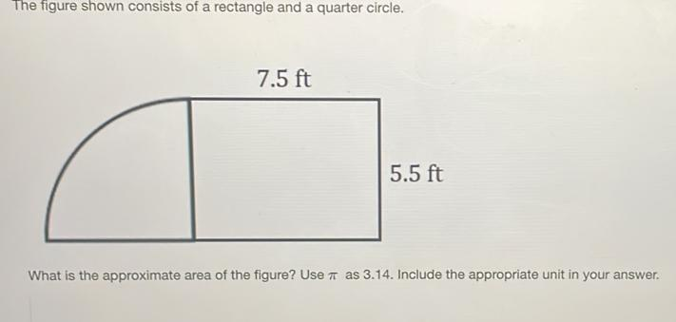
This type is common in composite-area geometry problems.

7. Polygon–Circular Segment Closed Shape
# Source: AI Source: Provided by: [Data Path: Persons Table -> ID Column: 1, Name_En Column: Motasem Essam] -> From: [ChatGPT] on [7/25/2026]
A polygonal portion combined with a circular segment.
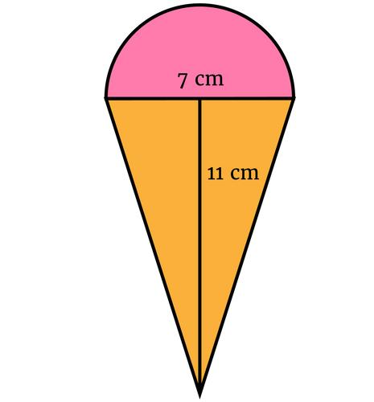
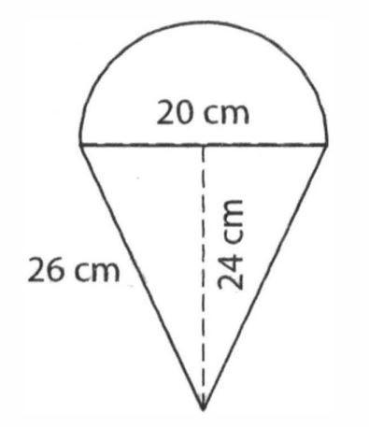
The circular segment is bounded by:
- A chord.
- A circular arc.

8. Polygon–Circular Sector Closed Shape
# Source: AI Source: Provided by: [Data Path: Persons Table -> ID Column: 1, Name_En Column: Motasem Essam] -> From: [ChatGPT] on [7/25/2026]
A polygonal component combined with a circular-sector boundary.
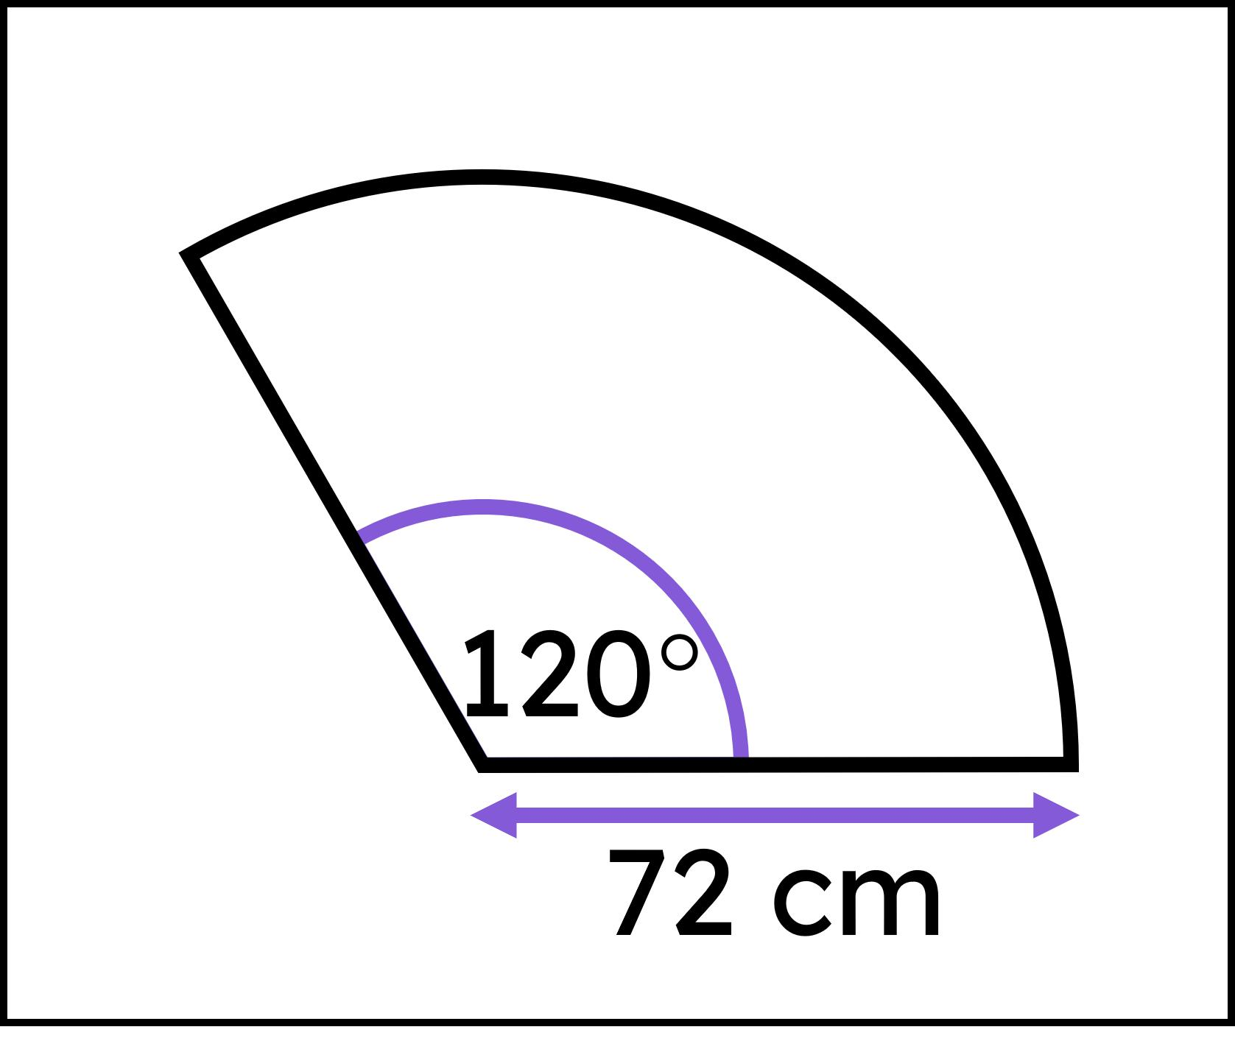
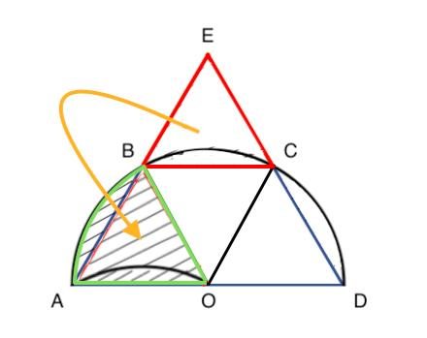
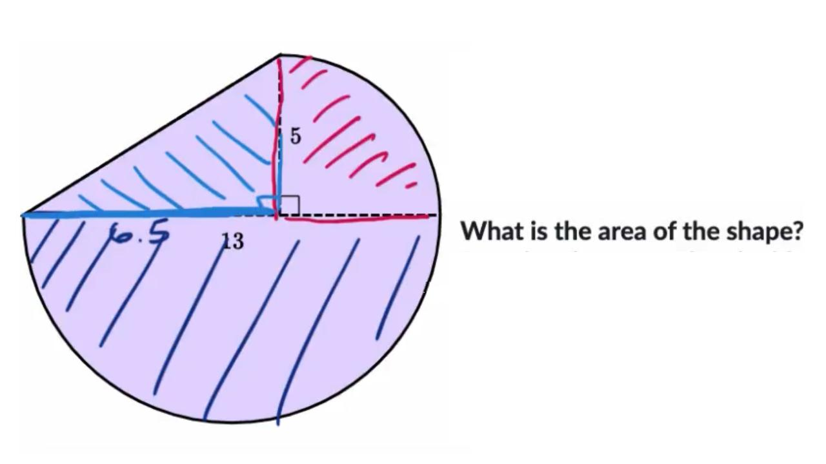
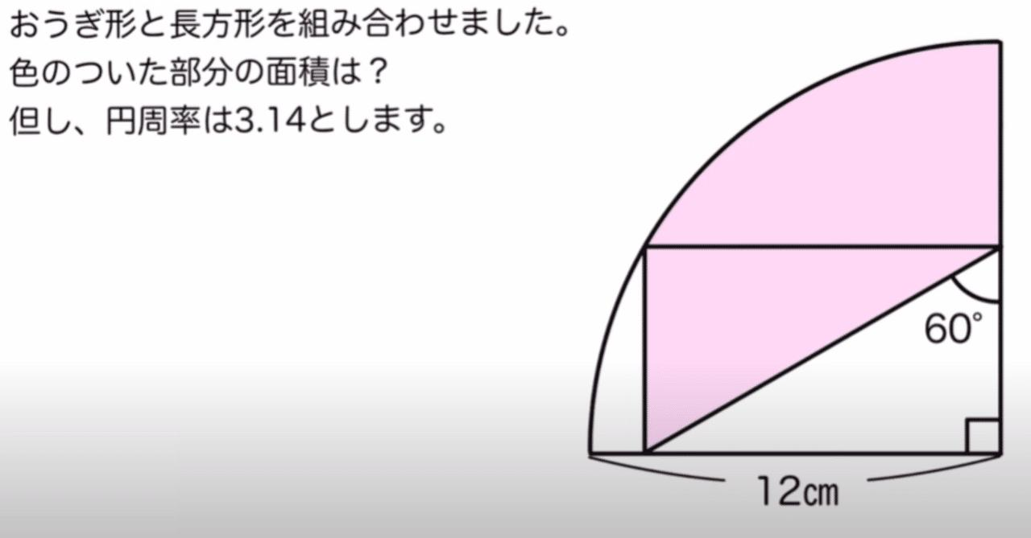
A circular sector contains:
- Two radii.
- One circular arc.
When combined with polygonal portions, the complete boundary becomes mixed.

9. Polygon with Circular Corners
# Source: AI Source: Provided by: [Data Path: Persons Table -> ID Column: 1, Name_En Column: Motasem Essam] -> From: [ChatGPT] on [7/25/2026]
A polygon-like shape whose sharp corners are replaced by circular arcs.
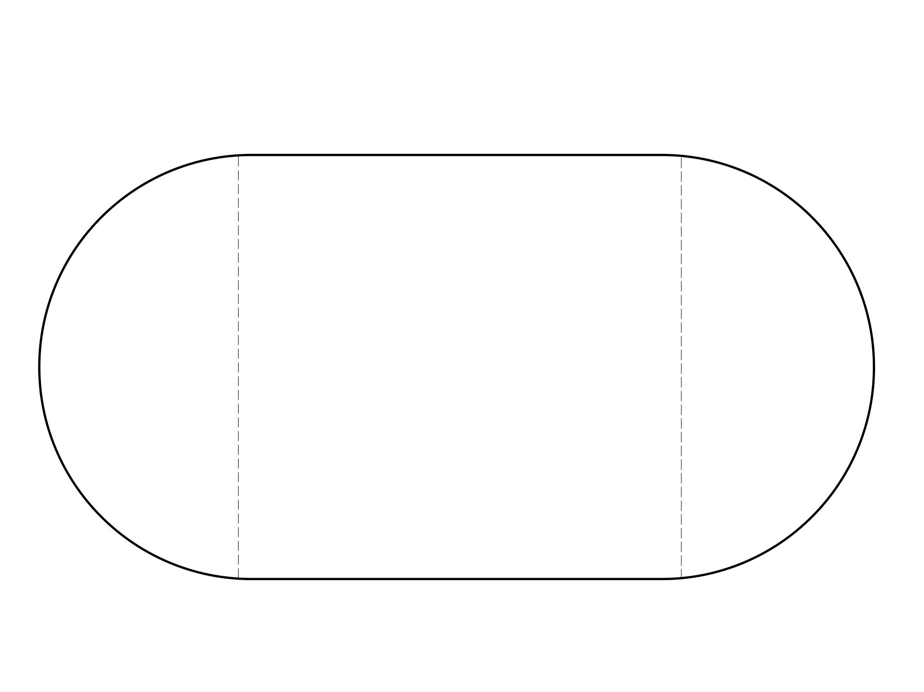
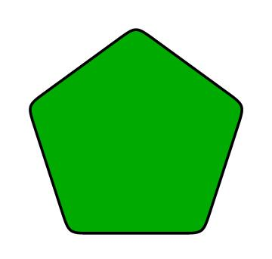
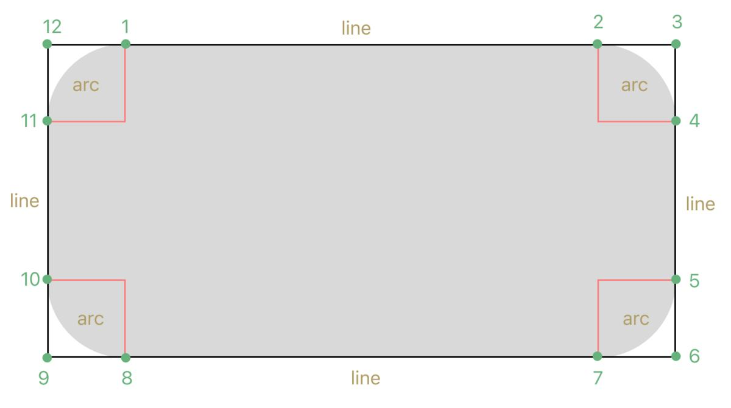
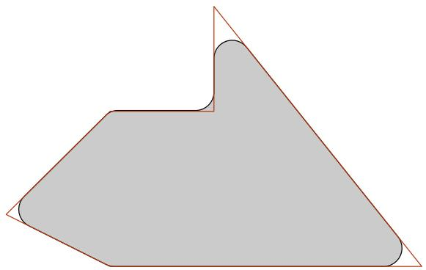
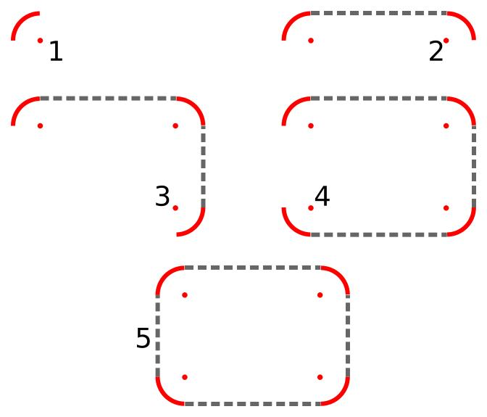
For example, a rectangle with rounded corners contains:
$$\boxed{\text{Straight Segments}+\text{Circular Arcs}}$$
This is one of the most common polygon–circular mixed shapes.

10. Irregular Polygon–Circular Closed Shape
# Source: AI Source: Provided by: [Data Path: Persons Table -> ID Column: 1, Name_En Column: Motasem Essam] -> From: [ChatGPT] on [7/25/2026]
An irregular polygon combined with circular arcs of different sizes or positions.
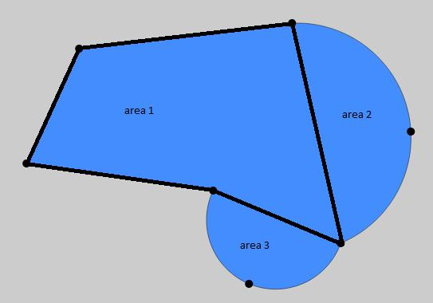
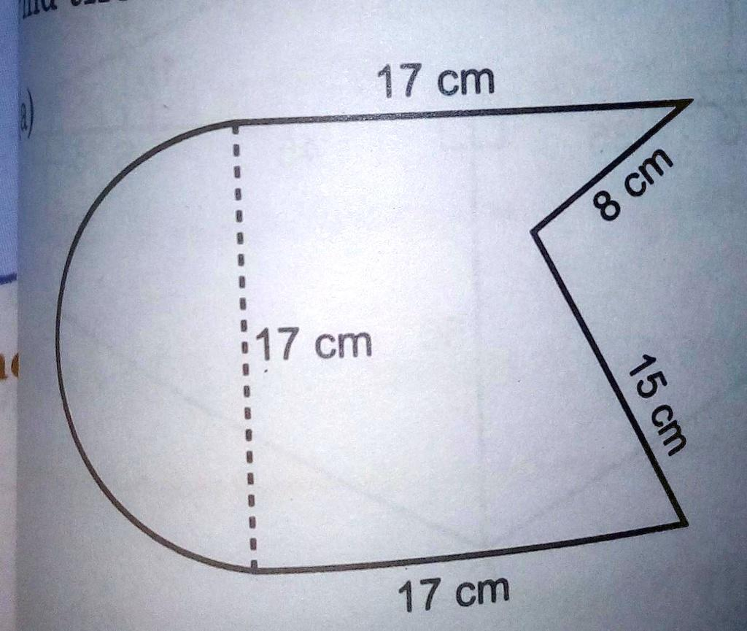
This type can contain:
- Unequal straight segments.
- Unequal angles.
- Circular arcs with different radii.
- Asymmetric placement of curves.

Classification by Polygon Type
# Source: AI Source: Provided by: [Data Path: Persons Table -> ID Column: 1, Name_En Column: Motasem Essam] -> From: [ChatGPT] on [7/25/2026]
The category can be organized according to the polygonal component:
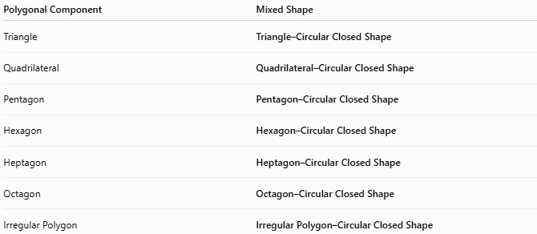
Polygonal Component | Mixed Shape
Triangle | Triangle–Circular Closed Shape
Quadrilateral | Quadrilateral–Circular Closed Shape
Pentagon | Pentagon–Circular Closed Shape
Hexagon | Hexagon–Circular Closed Shape
Heptagon | Heptagon–Circular Closed Shape
Octagon | Octagon–Circular Closed Shape
Irregular Polygon | Irregular Polygon–Circular Closed Shape

Classification by Circular Component
# Source: AI Source: Provided by: [Data Path: Persons Table -> ID Column: 1, Name_En Column: Motasem Essam] -> From: [ChatGPT] on [7/25/2026]
It can also be classified according to the curved portion:
- Polygon–Circular Arc
- Polygon–Semicircular
- Polygon–Quarter-Circular
- Polygon–Circular Segment
- Polygon–Circular Sector
- Polygon with Circular Corners
- Polygon with Multiple Circular Arcs

Polygon–Circular vs. Polygonal Shapes
# Source: AI Source: Provided by: [Data Path: Persons Table -> ID Column: 1, Name_En Column: Motasem Essam] -> From: [ChatGPT] on [7/25/2026]
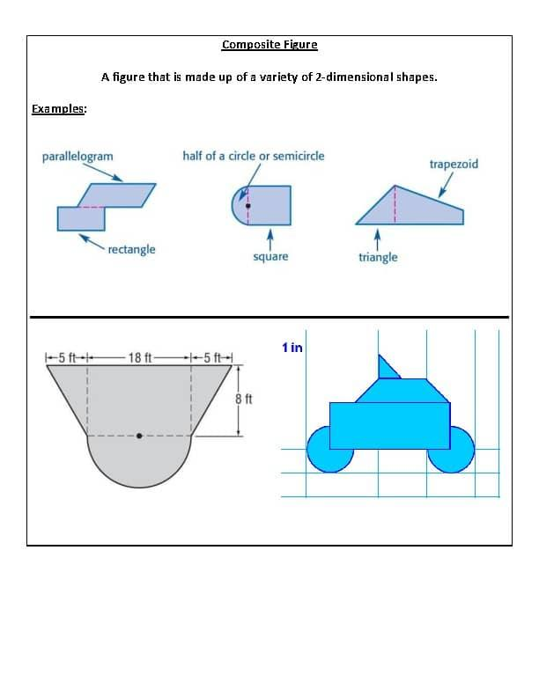
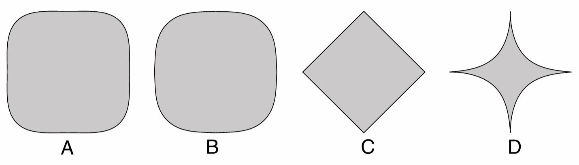
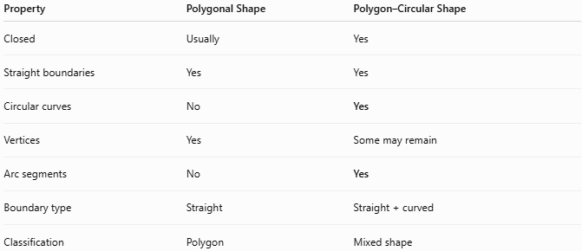
Property | Polygonal Shape | Polygon–Circular Shape
Closed | Usually | Yes
Straight boundaries | Yes | Yes
Circular curves | No | Yes
Vertices | Yes | Some may remain
Arc segments | No | Yes
Boundary type | Straight | Straight + curved
Classification | Polygon | Mixed shape
Therefore:
$$\boxed{\text{Polygon–Circular Shape}∉\text{Pure Polygonal Shapes}}$$
because its boundary contains curved portions.

Area
# Source: AI Source: Provided by: [Data Path: Persons Table -> ID Column: 1, Name_En Column: Motasem Essam] -> From: [ChatGPT] on [7/25/2026]
Polygon–circular closed shapes are often treated as composite shapes.
Their area can be calculated by decomposing the shape:
$$\boxed{A_{\text{total}}=A_{\text{polygon}}±A_{\text{circular part}}}$$
For example, a rectangle with a semicircle attached:
$$\boxed{A=lw+\frac{1}{2}πr^{2}}$$
The exact formula depends on how the polygon and circular components overlap.

Perimeter
# Source: AI Source: Provided by: [Data Path: Persons Table -> ID Column: 1, Name_En Column: Motasem Essam] -> From: [ChatGPT] on [7/25/2026]
The perimeter consists of both straight and curved portions:
$$\boxed{P=L_{\text{straight}}+L_{\text{curved}}}$$
For a circular arc:
$$\boxed{L_{\text{arc}}=rθ}$$
when (\theta) is measured in radians.
For a semicircle:
$$\boxed{L_{\text{semicircle}}=πr}$$
So a composite perimeter may contain both line lengths and arc lengths.

Key Points
# Source: AI Source: Provided by: [Data Path: Persons Table -> ID Column: 1, Name_En Column: Motasem Essam] -> From: [ChatGPT] on [7/25/2026]
A Polygon–Circular Closed Shape is:
$$\boxed{\text{Straight Polygonal Boundary}+\text{Circular Boundary}+\text{Closed Shape}}$$
It:
- Is completely closed.
- Contains both straight and curved boundary portions.
- Has at least one polygonal component.
- Has at least one circular component.
- Can be regular or irregular.
- Can be symmetric or asymmetric.
- Can be decomposed into polygonal and circular parts for area and perimeter calculations.

Conclusion
# Source: AI Source: Provided by: [Data Path: Persons Table -> ID Column: 1, Name_En Column: Motasem Essam] -> From: [ChatGPT] on [7/25/2026]
Polygon–Circular Closed Shapes are composite closed shapes that combine polygonal straight segments with circular arcs or circular portions. They include triangle–circular, quadrilateral–circular, pentagon–circular, hexagon–circular, polygon–semicircular, polygon–quarter-circular, polygon–circular segment, polygon–circular sector, rounded-corner polygon, and irregular polygon–circular shapes. Their defining characteristic is that their closed boundary contains both straight and circular curved components.

